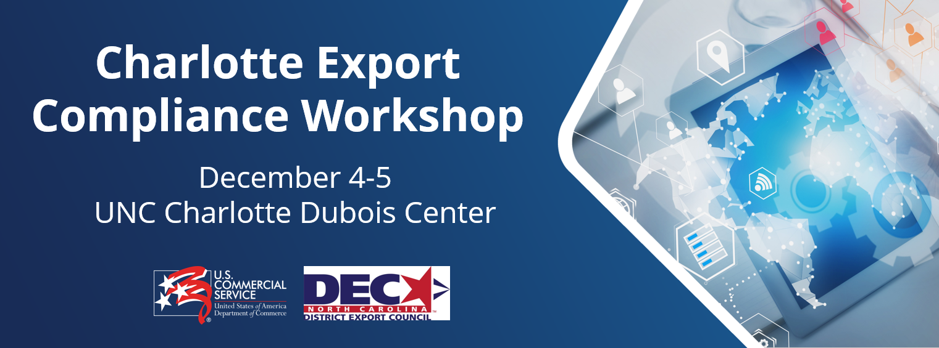

SPONSORSHIP OPPORTUNITY
The 2024 Export Compliance Roadshow is an excellent opportunity to position your organization as a market leader in promoting trade and export compliance worldwide. This unique two-day event will feature U.S. government experts on the rules and regulations that govern the landscape of export compliance, as well as private sector practitioners who will highlight their experiences and best practices. Given the important nature and wide application of the topics covered, and the opportunity for attendees to engage in Q&A sessions and discussions with government and industry experts. By sponsoring this event, your company will be contributing to the education and growth of the North Carolina export compliance community. We expect a sell-out capacity of 200 attendees. Early Bird registration (October 28) is $450.

Sponsorship Opportunities:

Your organization will have the opportunity to:
- Promote your brand, products, and services to hundreds of attendees.
- Participate in discussions and ask questions regarding export compliance regulations and best practices with representatives from multiple U.S. government agencies and private sector industry leaders.
- Network with U.S. exporters.

Your organization will be recognized according to your selected level of participation:

BECOME A SPONSOR TODAY!
Sponsorship Level | Platinum | Gold | Silver
Benefits | $2,500 | $1,500 | $750
Conference Tickets | 4 | 2 | 1
Logo on front cover of electronic Conference binder | X
Opening event comments to all attendees for both days | X
Special Thank You as Platinum Sponsor from conference podium | X
Logo will appear on presentation website at least 3 months after event | X | X
Selection priority of placement in exhibit space (skirted table provided) | First Choice | Second | Third
Company promotional items may be distributed to conference attendees from the exhibit space. | X | X | X
Listing as sponsor on promotional conference emails and social media promotions | X | X | X
Listing as sponsor with logo on event website | X | X | X
Listing & logo in electronic Conference binder | X | X | X
List of opt-in companies attending event | X | X | X
Special mention from Conference podium | X | X | X

Event Dates: December 4-5, 2024
Location: UNC Charlotte DuBois Center Uptown
320 E. 9th St. Charlotte, NC 28202

More Information, contact:
Greg Sizemore
U.S. Commercial Service, Charlotte NC
Greg.Sizemore@trade.gov

(704) 333-0471
THANK YOU FOR YOUR SUPPORT!
U.S. Department of Commerce | International Trade Administration | U.S. Commercial Service

